**RUMAH HOPE PROJECT PROPOSAL**



Group Members: 1. Ho Yen Liang 0326660

2. Christal Wong Ching Ling 0326715

3. Alexander Jose-Cheah 0326803

4. Ahmad Nabil b. Jimi 0327780

5. Chevally Lo Zhao Shyen 0326497

6. Tang Soon Foo 0330958

7. Poh Jia Yen 0331197

8. Vivien Ng Su-Qi 0326476

9. Ahmad Qhalis bin Ahmad Mukhlas 0326552

10. Lin Shan En 0331085

11. Sak Kar Wai (Ryan) 0326525

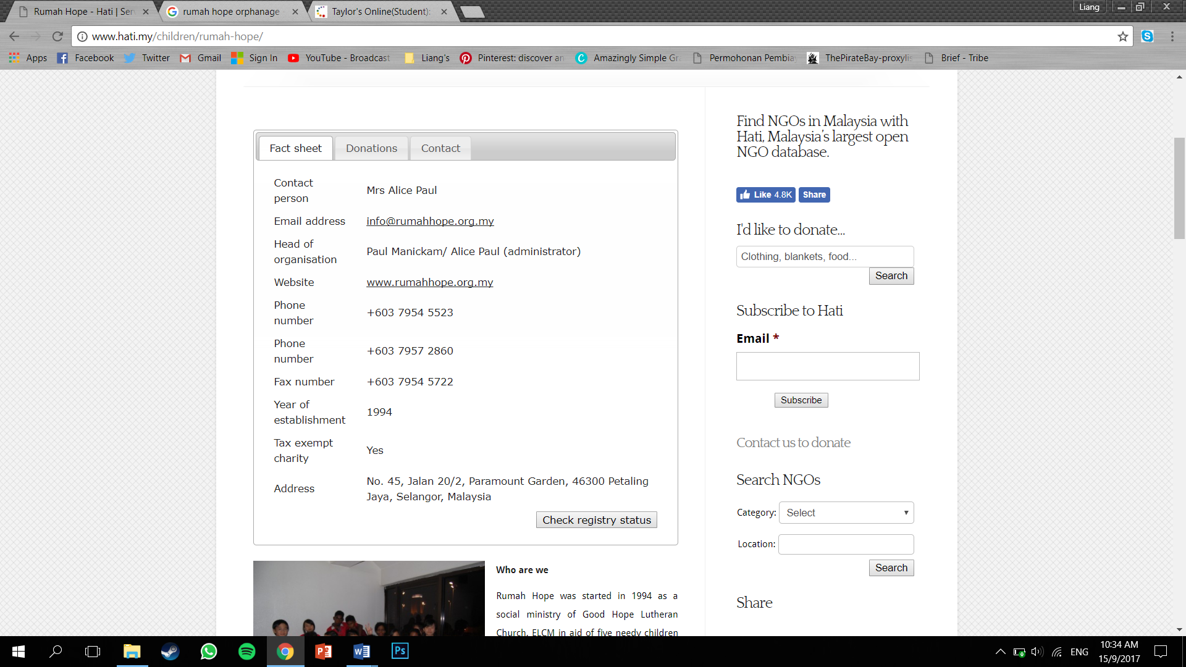

Additional Email: [rajes@rumahhope.org.my](mailto:rajes@rumahhope.org.my)

**PROPOSAL**

**Introduction**

Rumah Hope was started in 1994 as a social ministry of Good Hope Lutheran Church, ELCM in aid of five needy children and as a sanctuary for abused, neglected and under-privileged children between the ages of five to 17. The Home relies solely on **public funding** to maintain itself.

After four years, the Home moved from an old rented bungalow in Old Klang Road to the new home Rumah Hope 1 in Paramount Garden, PJ. The construction of the home was possible thanks to generous contributions in cash and kind namely from Evangelical Lutheran Church Malaysia, Khalid Aluminium Industries Sdn Bhd, NGO’s the general public and various corporate bodies. Rumah Hope 2, a second block was opened on 10th October 2006. Rumah Hope and Rumah Hope 2 will be able to house a maximum of 70 children. The Home is which is registered with Registrar of Societies is also registered with the Selangor Welfare Council and it has been granted Tax Exemption status by the Ministry of Finance.

Rumah Hope aims to provide a suitable social setting with physical and emotional care to children. From that, we will be looking into the community issues faced by this non-profit organization. The lack of both non-financial & financial help, as well as volunteers for helping hands, we can contribute our part to help solve and protect the children in need. The **reason** we chose orphanages to help out is because we want to provide the basic necessities to the children. These children are the leaders of our future generation, it will be a pleasure to support and motivate them to achieve their goals and dreams, without being treated differently from anyone.

**Management Committee**

The Present Management Committee, led by the chairman Jacob Mathew comprises of voluntary members from Good Hope Lutheran Church and other churches under the Evangelical Lutheran Church Malaysia (ELCM) together with individuals from private companies. All the management members are active in public life and are ardent supporters of various public welfare organizations.

**Organisation’s Source of Funding**

Along with the organisation’s efforts to secure funds, a request for an annual government grant is being made annually. With government aid backing us, the possibility of extending our reach to more children becomes very real.

**The organization’s need**

With the lack of financial as well as non-financial support, there are a few important things the organization is in need of:

* Lack of greeneries (gardening)
* Broken Cupboard Lock at the girl’s dormitory
* Repainting the worn-out wall
* Create blinds for the storage room’s windows

**Our Task**

* We are able to fix some of the furniture and equipments which are already old and worn out, instead of replacing them with new ones.
* We are proposing to build and design planter boxes, which are made from recycled/reused materials, to apply new plantations on the site.
* Educating the children there on how to plant and garden, giving them an experience and opportunity to interact and approach others. In the meantime, to show importance of using greeneries to strengthen the idea of environmental sustainability design.
* Spending quality time with the children there, educating and interacting with them by having interesting games and activities together.

**Service Timeline & Details**

* 5 weeks
* 4 hours minimum per week spent

|  |  |
| --- | --- |
| Week |  |
| 4 | * Site Analysis * Proposal * Budget * Design Work * Propose Design Work * Finalise Design |
| 5 | * Gather Materials and tools * Work distribution * Making :-  1. Gardening – Prepare planter boxes, involving kids in gardening 2. Repairing cupboard locks @ girls’ dormitory 3. Repainting walls 4. Mural Art \*\*TBC 5. Blinds for store room |
| 6 | * Making & Installation :-  1. Gardening – Installing planter boxes, kids are involved for lighter works 2. Repainting walls 3. Repair Cupboard Lock – we will teach them how to fix |
| 7 | * Making & Installation :-  1. Gardening – second area , installing – kids involved in smaller scale 2. Repainting walls – kids can help painting |
| 8 | * Making & Installation  1. Gardening – Kids painting their own art on the planter boxes 2. Repainting walls/ gardening – the kids can help painting 3. Mural Arts |
| 9 | * Making & Installation  1. Gardening – teaching kids to garden and take care of plants 2. Interacting & engaging with the kids 3. Mural Art – Involving the kids with the paintings too 4. Cleaning up |
| 10 | * Report * Video Editting |

**SITE PLAN**

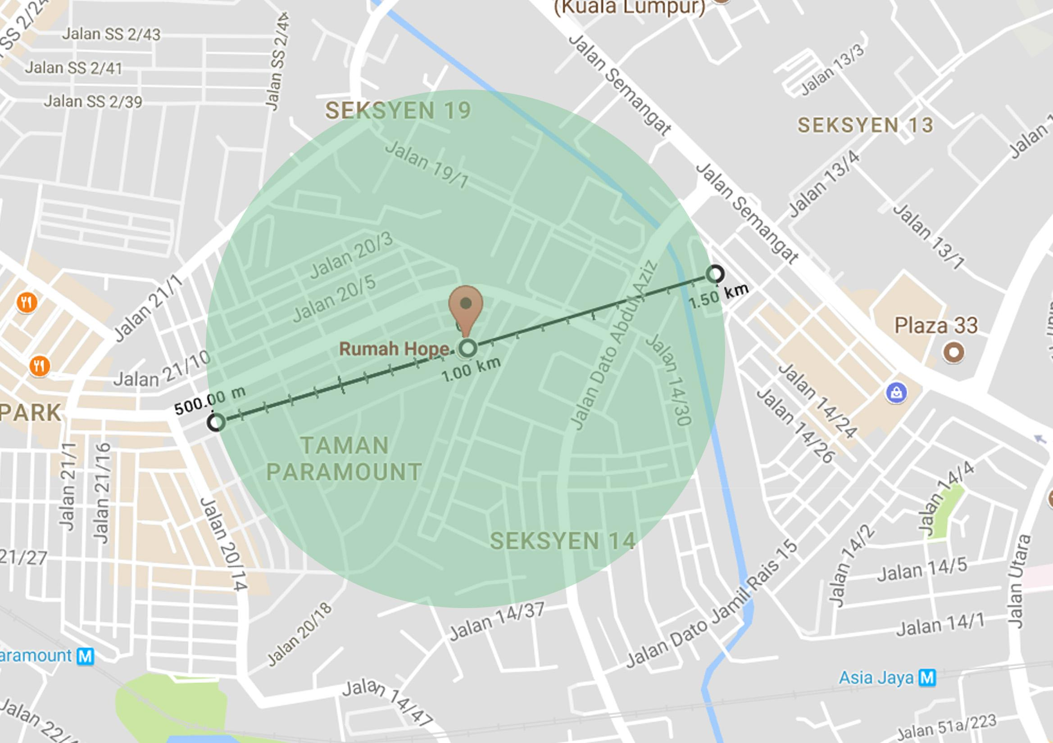

**Site Area: 500m Radius**

**Mall**

* 3 Two Square

**Restaurants**

* Fluffed Dessert Cafe
* Thai Camp pj
* Tian Pin Vegetarian
* Paparich
* OldTown
* Restoran Al-Safuan
* Lunchbox
* Quencher’s Restaurant & Pub

**Religious Building**

* Madrasah Salahuddin
* Masjid Tun Abdul Aziz

**Education Building**

* Wisma Academy
* Open University

**Offices**

* Malaysia-Australia Business Council
* STATWORKS
* Fireworks Solution : Mobile App Development, Rewards & Loyalty Solutions
* RJP
* The Crest
* Celcom Transmission

**Shop Lots**

* Zenrue Herbs and Food Trading
* Perfect Vision Optical
* Electrical Supply Shop
* Joon-Li Machinery Hardware
* Best Auto Supplies
* Print Shop
* Phut Seet Fun

**Summary**

Our plan is to fix and build simple furnitures like beds and tables for the children of Rumah Hope, as architecture students ,we feel that we could benefit the society by helping how we could. At the mean time , as responsible individuals, we believe that it is important for the young and new generation to live in a greener place. Hence, educating and passing down the knowledge on learning how to build your own garden; from vegetations for basic living food to greener ecosystem to appreciating mother nature.

We will be using recycled materials to create beds, tables and etc, Kids able to take part during the entire process. We are very willing to share our university life experiences to the kids, as a great way to motivate kids. It is our pleasure for able to help out Rumah Hope as we will be also learning ways on how to contribute the society. Thank you.

Regards,

Christal Wong - 0173639936.

Ho Yen Liang (group leader) - 0126694368

**Gardening & Landscape Issues**

**Issues/Problems**

|  |  |
| --- | --- |
| 1. Large open spaces around the building are not fully utilized to create the most out of green and lively atmosphere. | **C:\Users\User\Downloads\IMG_8243 (1).JPGC:\Users\User\Downloads\IMG_8242.JPG**  **C:\Users\User\Downloads\IMG_9237.JPG**   1. Backyard |
| **C:\Users\User\Downloads\IMG_9260.JPG**  (b) Front porch |
| 2. Hazardous landscaping proved to be a threat to children’s safety   * might easily fall off from the 6.3 meter tall step * lack of a clear directed path which lead the way to the stairs at the side |  |

**Solutions**

1. (a) planter boxes to plant vegetation at the **backyard**
   * fully utilized the space to grow food instead of decorative plants
   * use recyclable and reusable materials to build the planter box
   * reduce environmental impact – avoid unnecessary air and water pollution without the use of pesticides and herbicides
   * engaging the children in this activity of growing their own food, providing a totally new and educational experience, and building them a sense of accomplishment to appreciate their own meal grown by themselves

(b) Green plants to lighten up the atmosphere at **front porch**

* to create a more sustainable and welcoming space
* utilizing the front porch to serve as a children’s play area, strengthening the idea of human relationship towards the environment

(c) Hanging creepers

* provides shading
* purifying the air – takes up carbon dioxide and gives out oxygen
* as this space is next to the road, plants grown here can absorb sound and help with noise pollution

1. Place planter boxes below the tall step (planter boxes need to be higher than the tall step in this case)

**Installation Project Cost**

|  |  |  |  |  |
| --- | --- | --- | --- | --- |
| **Materials** | **Sources** | **Cost** | **Quantity** | **Total Cost** |
| Organic Soil | Purchase | RM 10 (5 kg per pack) | 4 Packs | RM 40 |
| Multipurpose Soil | Purchase | RM 8 (5 kg per pack) | 8 Packs | RM 64 |
| Fertilizer | Purchase | RM 30 (3 kg) | 1 Pack | RM 30 |
| Plantation Seed (Flowering) | Purchase | RM 6 | 3 Packs | RM 18 |
| Plantation Seed (Vegetables) | Purchase | RM 3 | 2 Packs | RM 6 |
| Safety Gloves | Purchase | RM 1.50 | 12 Pairs | RM 18 |
|  |  |  |  | RM 176 |

**Painting**

**Issues**

|  |  |
| --- | --- |
| 1. Several wall surfaces requires repainting. Cracking and peeling of old paint should be removed. | (a) Covered Assembly Point  **C:\Users\Nicklaus Tang\AppData\Local\Microsoft\Windows\INetCache\Content.Word\IMG_9256.jpgC:\Users\Nicklaus Tang\AppData\Local\Microsoft\Windows\INetCache\Content.Word\IMG_8255.jpgC:\Users\Nicklaus Tang\AppData\Local\Microsoft\Windows\INetCache\Content.Word\IMG_8254.jpg**C:\Users\Nicklaus Tang\AppData\Local\Microsoft\Windows\INetCache\Content.Word\IMG_9244.jpgC:\Users\Nicklaus Tang\AppData\Local\Microsoft\Windows\INetCache\Content.Word\IMG_9245.jpg |
| (b) Boy’s Dormitory  C:\Users\Nicklaus Tang\AppData\Local\Microsoft\Windows\INetCache\Content.Word\IMG_9253.jpg**C:\Users\Nicklaus Tang\AppData\Local\Microsoft\Windows\INetCache\Content.Word\IMG_8258.jpg**  C:\Users\Nicklaus Tang\AppData\Local\Microsoft\Windows\INetCache\Content.Word\IMG_9243.jpg |
| 2. Window frames are beginning to rust. New coat of paint required. | C:\Users\Nicklaus Tang\AppData\Local\Microsoft\Windows\INetCache\Content.Word\IMG_9238.jpg**C:\Users\Nicklaus Tang\AppData\Local\Microsoft\Windows\INetCache\Content.Word\IMG_9242.jpg**(a) Office window frames |

**Solutions**

1. Remove any molds or damaged paint and apply a new layer of paint on it.

* Provides a cleaner and more polished environment for the kids to play and gather.
* Eliminates any health risks.
* A new coating will provide additional protection for the wall and allow it to last longer.
* Educate the children to maintain and take care of the home they lived in.

1. Reapply a new coat to window frames.

* Prevent the walls from getting soiled again from rust stains.
* Eliminates health risks.
* Provides protection for the frames to prevent rust which eliminate the need to have them replaced.

**Installation Project Cost**

|  |  |  |  |
| --- | --- | --- | --- |
| **Materials** | **Cost** | **Quantity** | **Total Cost** |
| Thinner | RM 3.30 | 3 | RM 10 |

**Blinds/Curtains**

**Issues**

|  |  |
| --- | --- |
| 1. Children tend to place hands into window slits and try to grab items in store room. This is due to a missing glass panel on the window and there is proper curtains to cover it. Currently black paper is only used and can be easily torn. | 1. Black Paper and tape is currently used. |

**Solutions**

Layered the newspaper and tape them to strengthen it and nail to the sides of the window frame. This provides a tougher and more resistant material to provide protection of kids poking into window holes. Also, covers the whole window area.

**Installation Project Cost**

|  |  |  |  |  |
| --- | --- | --- | --- | --- |
| **Materials** | **Sources** | **Cost** | **Quantity** | **Total Cost** |
| Tape | Purchase | RM | 3 Rolls | RM 11.10 |